* INTRODUCTION

An airplane crash analysis is a detailed investigation into the causes of an aviation accident. The goal of an airplane crash analysis is to identify any factors that contributed to the accident, with the ultimate goal of improving safety and preventing future accidents. The process of conducting an airplane crash analysis typically involves the collection and analysis of a wide range of data, including information about the aircraft and its systems, the operators, and any other relevant factors. This data is typically collected from Kaggle. Once the data has been collected, it is analysed through tableau, to identify any potential causes of the accident. The results of an airplane crash analysis are typically published in a report, which may include recommendations for improving safety and preventing similar accidents in the future. These recommendations may be implemented by the relevant authorities or industry organizations.

* PROBLEM DEFINITION & DESIGN THINKING

2.1 EMPATHY MAP

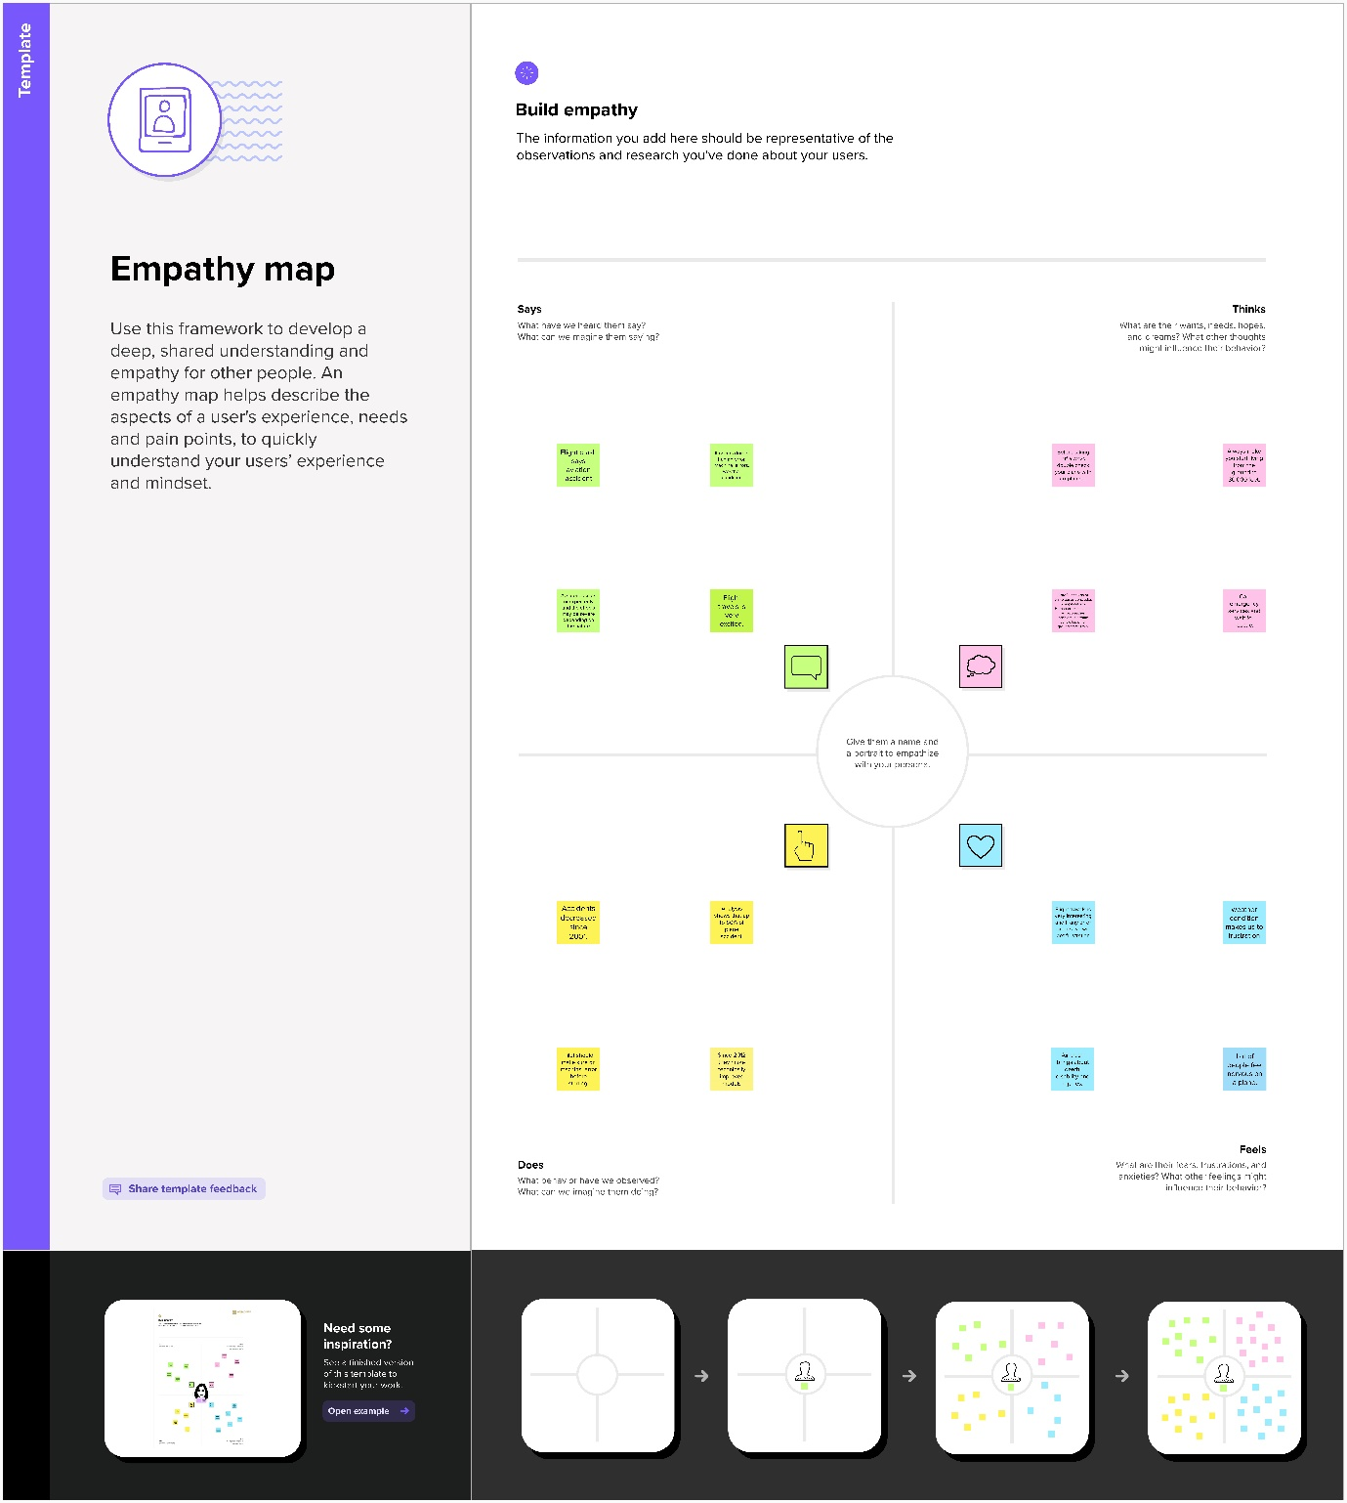

2.2 IDEATION &BRAINSTORMING MAP

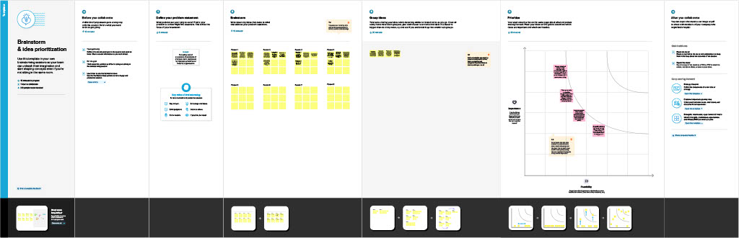

* RESULT

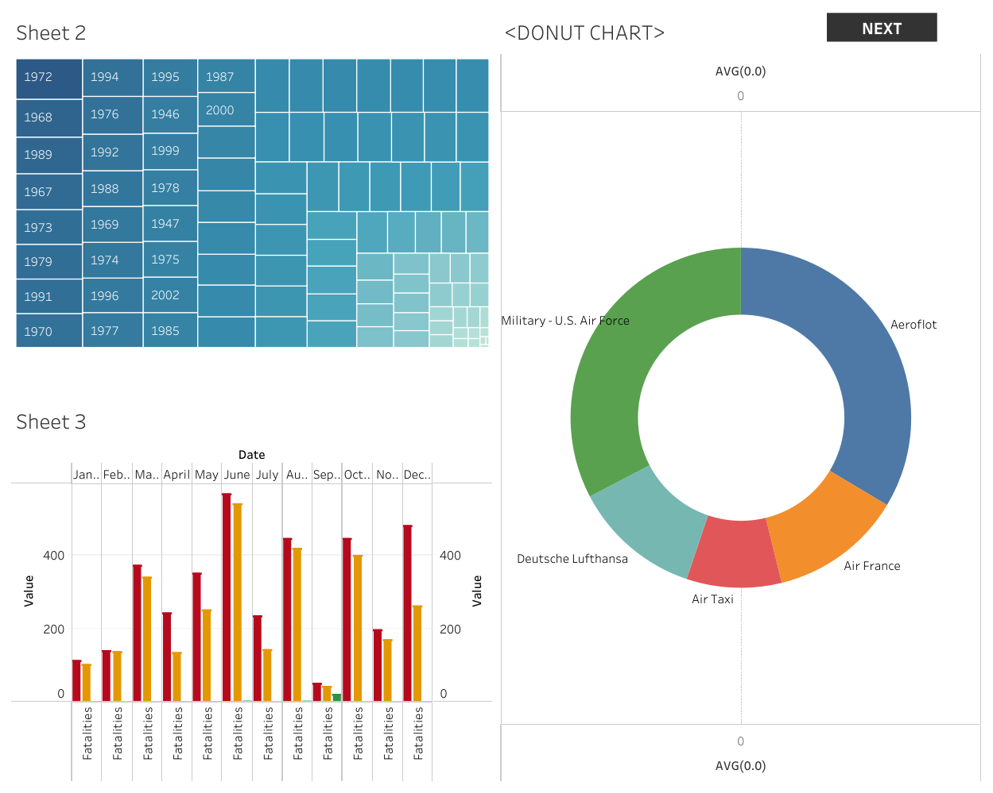

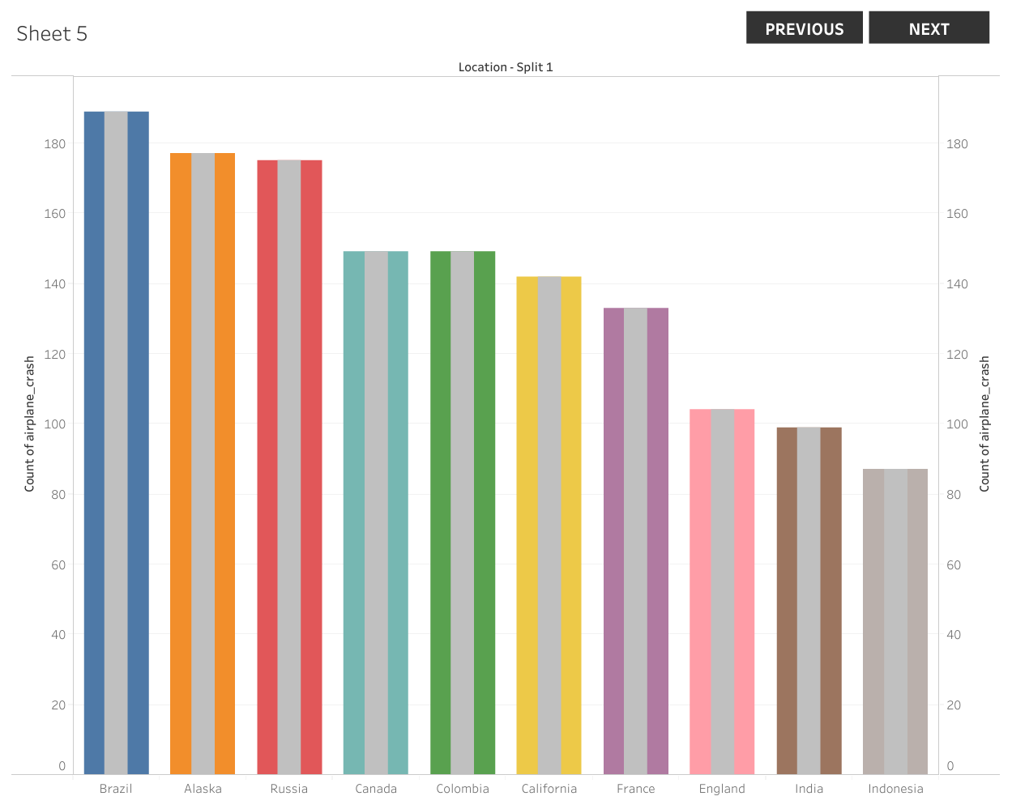

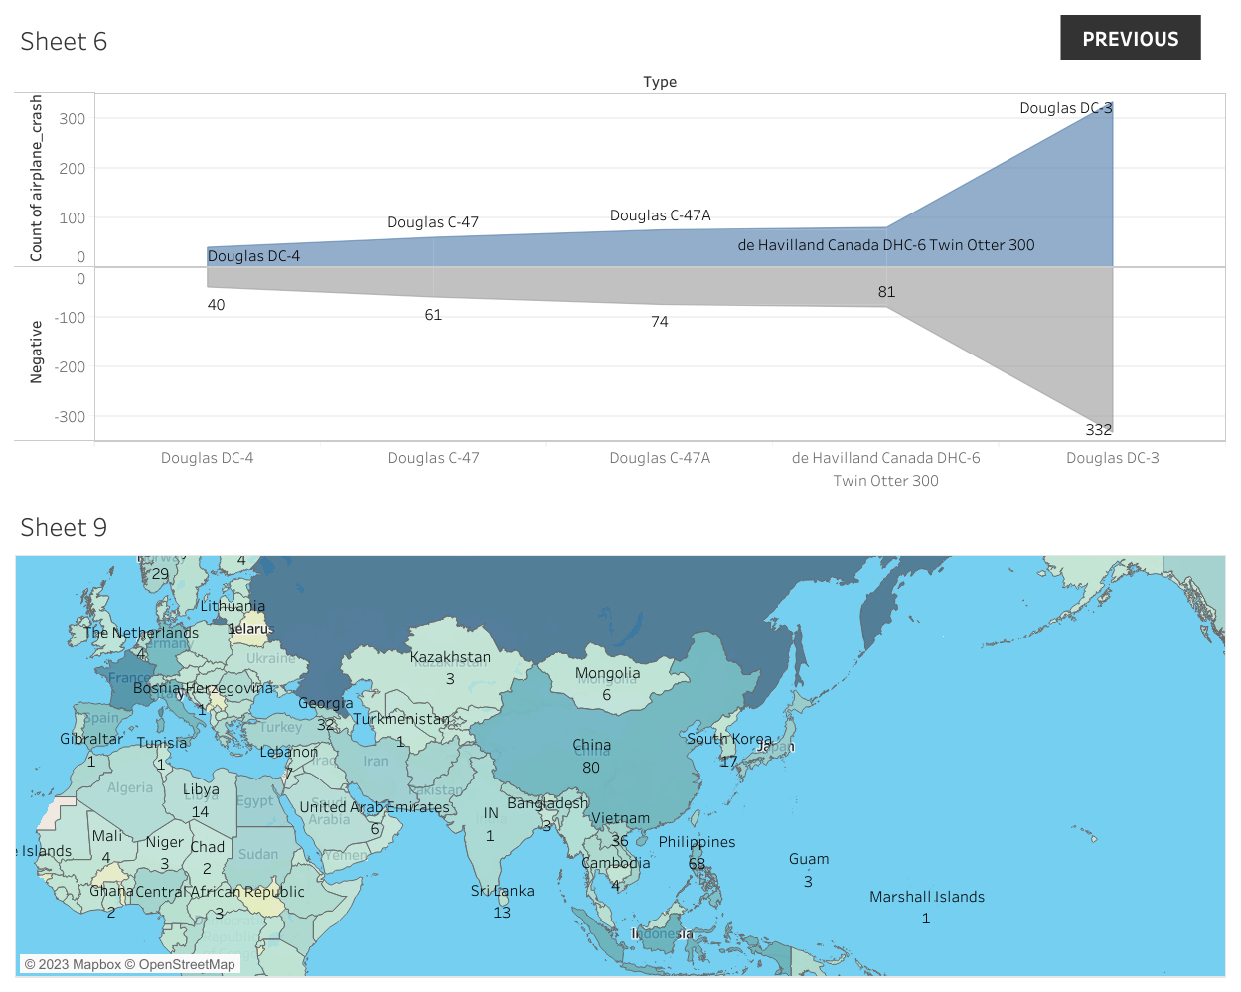

* CONCLUSION

The 35 mph frontal barrier crash Repeatability Test Program (RTP) conducted by the National Highway Traffic Safety Administration (NHTSA) resulted from concerns over the significance of New Car Assessment Program data derived from a single crash test and the repeatability of that crash test data. To help identify and quantify, to the extent possible, the sources of variation, the agency initiated the RTP. The program consisted of a minimum of four frontal barrier impacts of 1982 Chevrolet Citations at three different test sites, and resulted in a total of fourteen tests. The fourteen identical make and model test vehicles were manufactured consecutively on the same production line in the same assembly plant in an attempt to achieve maximum possible uniformity. The NHTSA test sites were Calspan Corporation, Buffalo, New York; Dynamic Science Inc., Phoenix Arizona; and the Transportation Research Center, East Liberty, Ohio. The RTP data was analyzed to examine data variability due to test facility, test instrumentation, test procedure, the test dummy and the test vehicle. The analysis also examined any correlation that existed within the various data results

* FUTURE SCOPE

Never leave your feet. Hassle-free flip-flops might seem like a good idea for braving airport security, but in the chaos of a crash or evacuation, they’ll only slow you down. Likewise, high heels can lead to stumbling, and may even be sharp enough to pop the inflatable exit slide. Wear a pair of comfy flats or sneakers, and keep them on your feet through the whole flight. Not only can loose shoes get in other passengers’ way and hinder your own mobility during an evacuation, but also remember that nobody wants to smell your stinky feet. And statistically, that is a far greater threat to air travel than any crash.

* APPENDIX

1. SOURCE CODE
2. DASHBOARD : <https://public.tableau.com/views/Book3_16814063661090/Dashboard3?:language=en-GB&:display_count=n&:origin=viz_share_link>
3. STORY : <https://public.tableau.com/views/Book4_16814064457230/Story1?:language=en-GB&:display_count=n&:origin=viz_share_link>